**Ques no: 1 - 6**

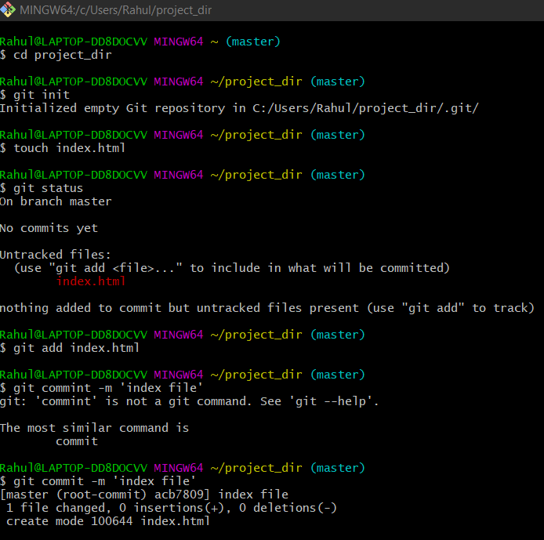

**Ques no: 7 - 8**

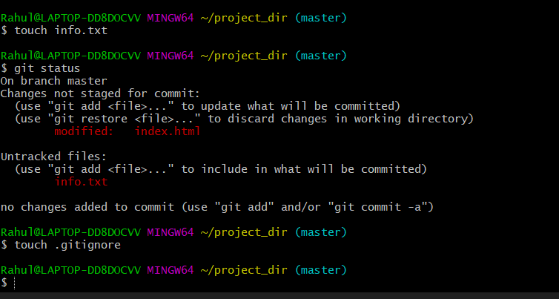

**Ques no: 9**

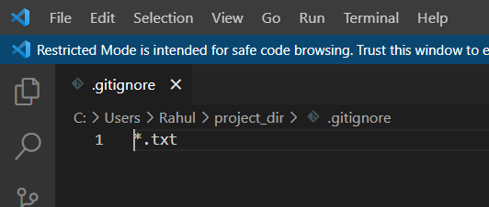

**Ques no: 10 - 14**

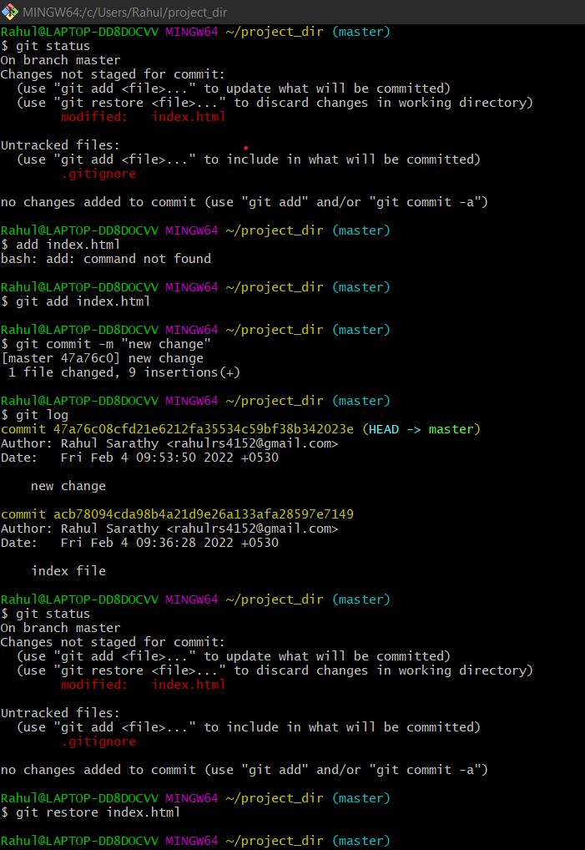

**Ques no: 14 – 19**

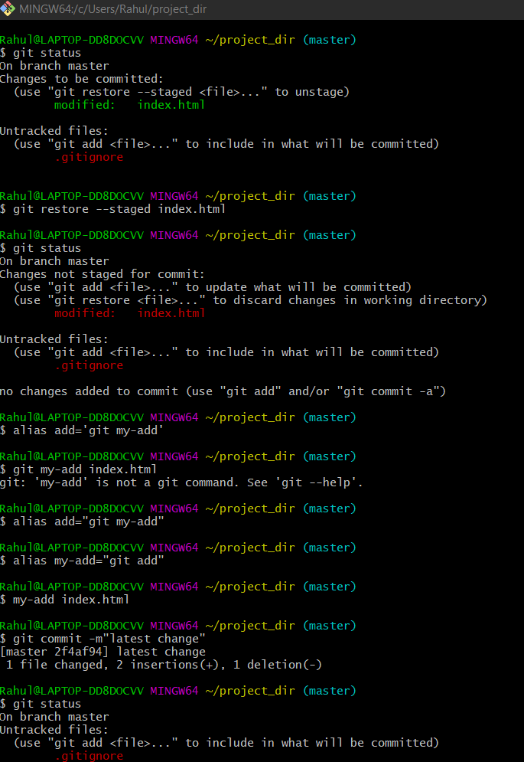

**Ques no: 20**

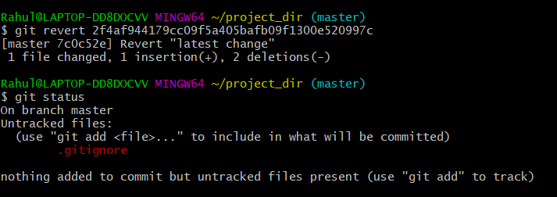

**GIT Branching**

**Section -1 (HTML)**

**Ques no: 21-26**

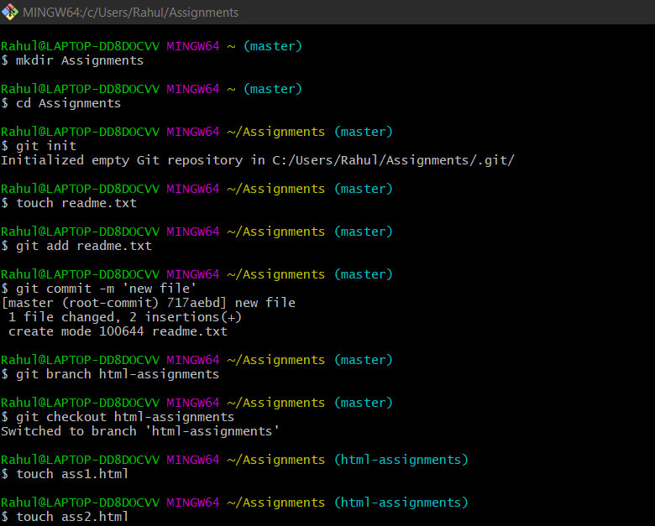

**Ques no: 27 – 28**

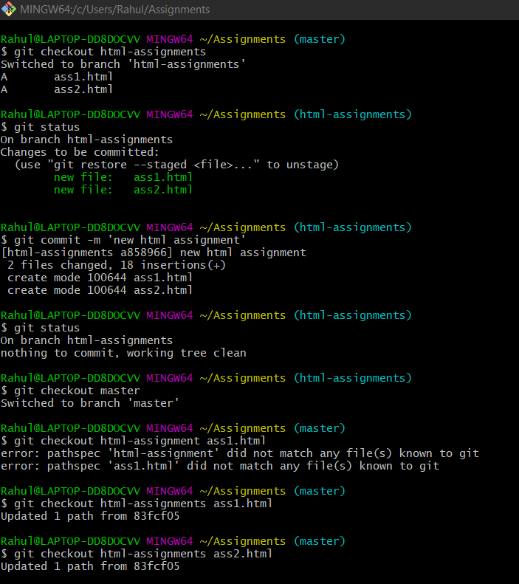

**Ques no: 29 – 33**

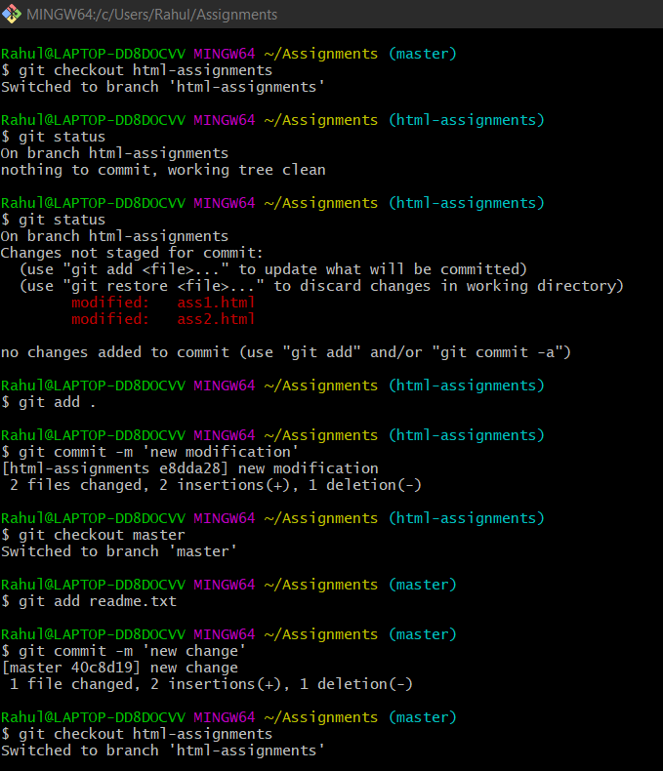

**Ques no: 34 – 38**

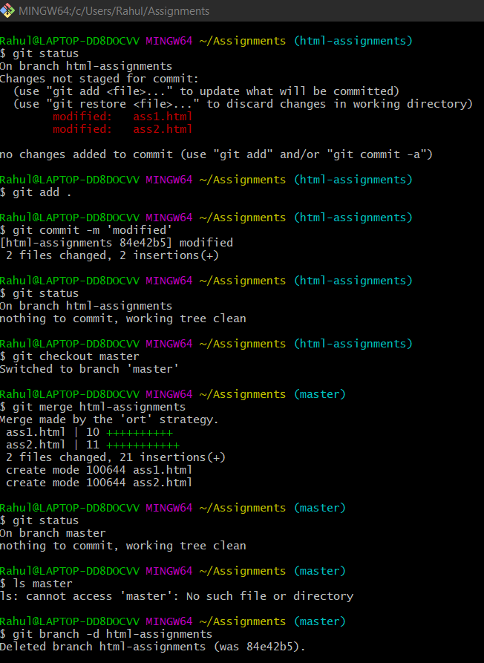

**SECTION – 2 (CSS)**

**Ques no: 1-2**

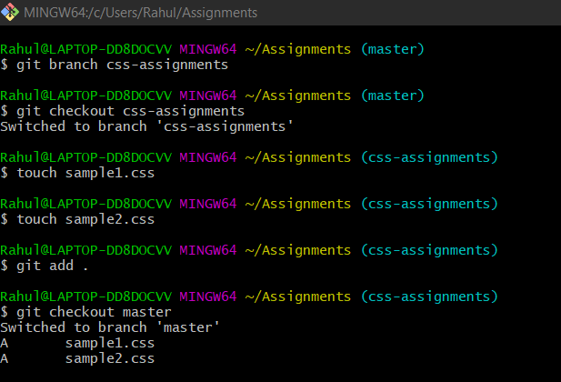

**Ques no: 3 & 4(I cleared the page without taking screenshot for this question so I used another command to show command history)**

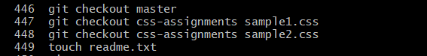

**Ques no: 5 - 8**

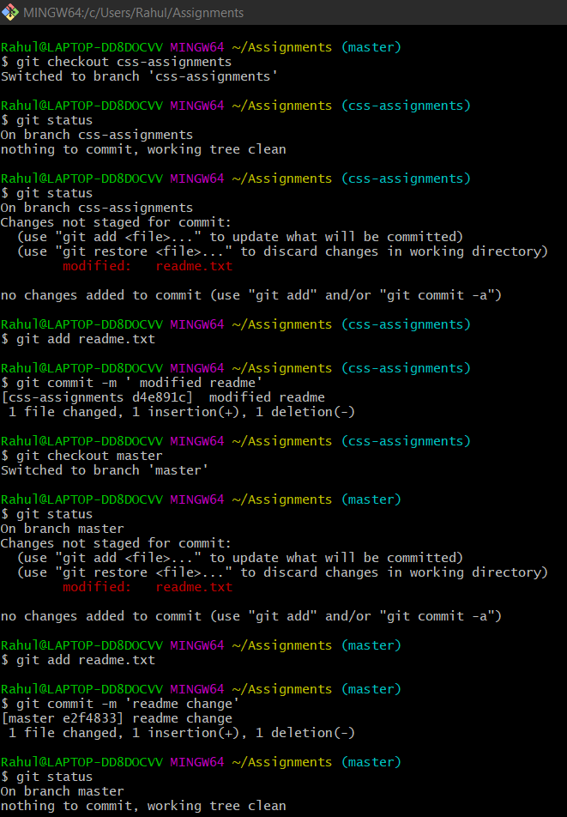

**Ques no: 9 – 14**

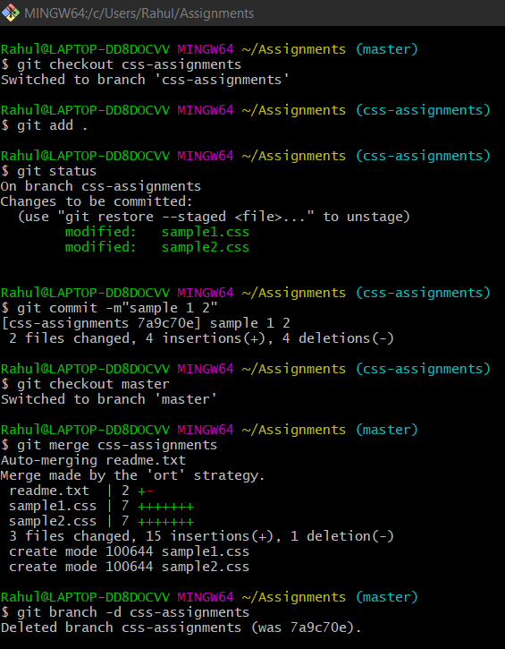

**SECTION-3 (JavaScript)**

**Ques no: 1 - 6**

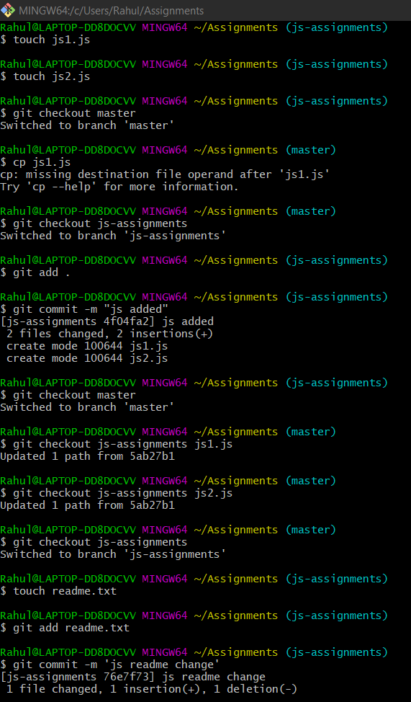

**Ques no: 7 – 11**

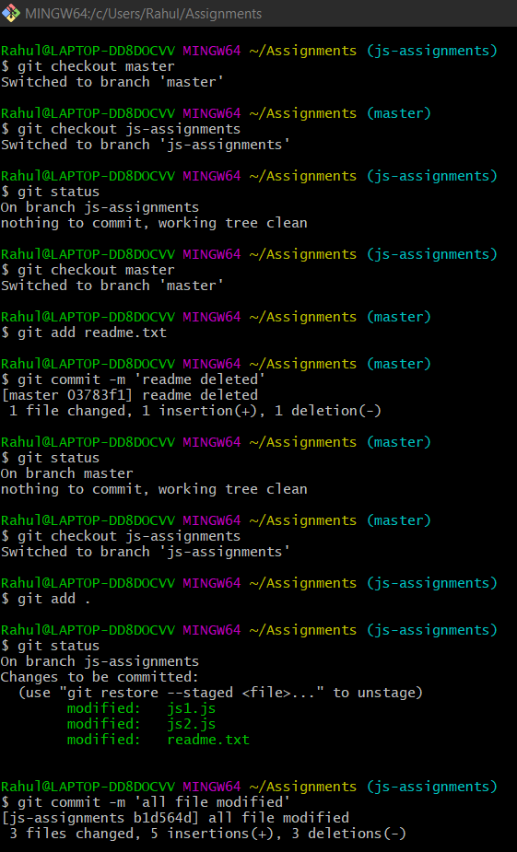

**Ques no: 12 -14**

